**AI Search techniques**

**Sudoku Problem :**

- Sudoku is a puzzle played on a partially filled 9 x 9 grid. The task is to complete the assignment using numbers from 1 to 9 such thatthe entries in eachrow, eachcolumn and each major 3 x 3 block are pairwise different. Below are given two tables;the first is showing aSudoku Problem and the second asolution to this problem.

- **You must implement one of the uninformed search techniques to solve this Problem.** - **Don’t use built in predicates except (Append,findall, bagof, setof,nth0, nth1,**

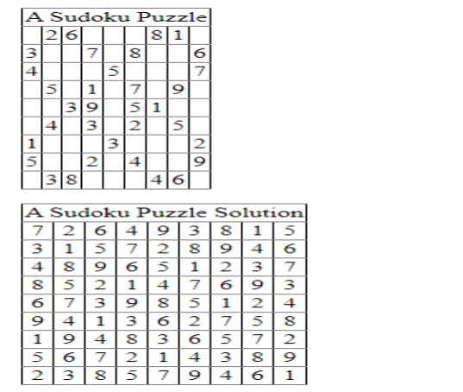**member, substitute, length).**